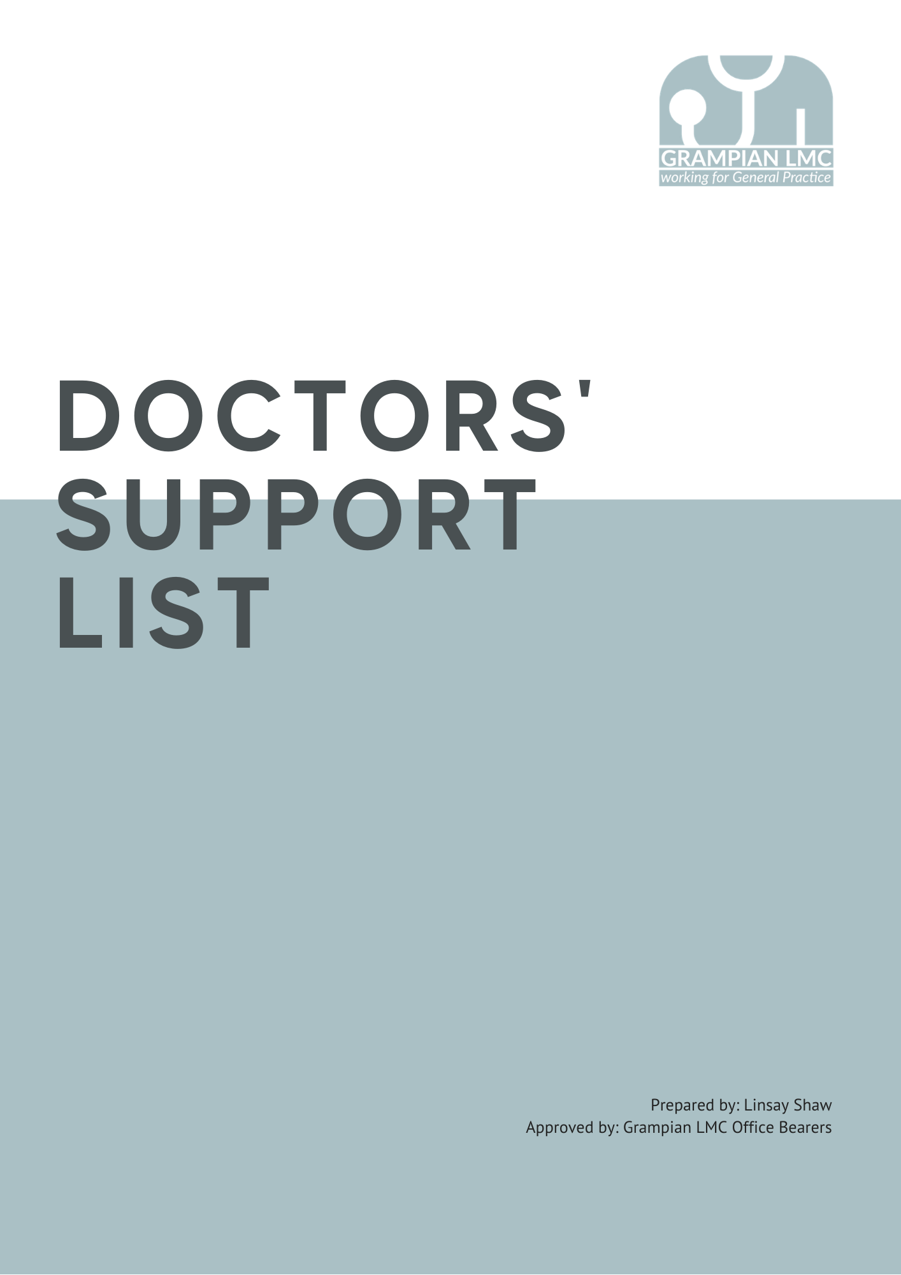

|  |  |  |
| --- | --- | --- |
| LOCAL | | |
| Issue/Problem Area | Organisation | Contact Details |
|  |  |  |
| COVID-19 | NHS Grampian Resilience Hub  The Psychological Resilience Hub is for anyone who has struggled with the impact of Covid-19 on their psychological wellbeing and is for anyone in Grampian or Orkney. It is open 6 days a week Monday – Friday 10am-8pm and Saturdays 10am-6pm. | [www.covid19.nhsgrampian.org/for-nhs-grampian-staff/self-care-for-staff/mental-health-and-wellbeing-general-information-for-staff/](http://www.covid19.nhsgrampian.org/for-nhs-grampian-staff/self-care-for-staff/mental-health-and-wellbeing-general-information-for-staff/) |
| Support | Grampian LMC  Grampian Local Medical Committee is the representative body for General Practitioners in Aberdeen, Aberdeenshire and Moray. One of the functions of the LMC is to provide pastoral care and support to colleagues in difficulty. The committee are offering a wellbeing call, to check in and let you know about the support we can offer. And If you feel you are struggling with any issue, personal, financial, professional please get in touch and we can confidentially provide support to you and being local can advise/signpost to any other local resources if required. | [www.grampianlmc.org](http://www.grampianlmc.org)  [office@grampianlmc.org](mailto:office@grampianlmc.org) |

|  |  |  |
| --- | --- | --- |
| WORKFORCE SPECIALIST SERVICE | | |
| Issue/Problem Area | Organisation | Contact Details |
|  |  |  |
| Workforce  Specialist Service | The WSS  Delivered by NHS Practitioner Health on an interim basis, is a confidential, multidisciplinary mental health treatment service with expertise in treating regulated health and social services professionals. They specialise in caring for regulated professionals as patients, and as such are experts at the interface between regulation, employment and mental illness and addiction. | <https://www.practitionerhealth.nhs.uk/accessing-the-service-in-scotland>  0300 0303 300  [prac.health@nhs.net](mailto:prac.health@nhs.net) |

|  |  |  |
| --- | --- | --- |
| NATIONAL | | |
| Issue/Problem Area | Organisation | Contact Details |
|  |  |  |
| Alcohol Abuse | Alcoholics Anonymous  Alcoholics Anonymous is a gathering of men and women who share their experience, strength and hope with each other, that they may recover and help others to recover from alcoholism. | [www.alcoholics-anonymous.org.uk](http://www.alcoholics-anonymous.org.uk)    0845 769 7555 |
| Bereavement | Cruse Bereavement Care  Offers free information and advice to anyone who has been affected by a death. | [www.cruse.org.uk](http://www.cruse.org.uk)    0808 808 1677    [helpline@cruse.org.uk](mailto:helpline@cruse.org.uk) |
| Carers Support | Carers UK  Millions of people are caring for elderly relatives, sick friends or disabled family members. They often do it unpaid or without support. Carers UK can provide information, advice and support for carers. | [www.carersuk.org](http://www.carersuk.org)    0808 808 7777 |
| Coaching Support | Joyful Doctor  Helps doctors to look after themselves, beat stress and burnout and thrive at the meaningful work they love. | www.joyfuldoctor.com  01932 922 100  [teamjoy@joyfuldoctor.com](mailto:teamjoy@joyfuldoctor.com) |
| COVID-19 | Practitioner Health Webinars and Podcasts  The latest webinars and podcasts, on managing your mental health and wellbeing during COVID-19. | <https://www.practitionerhealth.nhs.uk/webinars-and-podcast> |
| Crime | Victim Support Line  Victim Support is the national charity which helps people affected by crime. They provide free and confidential support to help deal with the experience, whether or not the crime is reported. | [www.victimsupport.org.uk](http://www.victimsupport.org.uk)  0845 30 30 900    [supportline@victimsupport.org.uk](mailto:supportline@victimsupport.org.uk) |
| Disability | Association of Disabled Professionals  Draws on the expertise of disabled professionals to improve the educational and employment opportunities of disabled people. | [www.adp.org.uk](http://www.adp.org.uk)  01204 431638 |
| Disability | Hope 4 Medics  A support group for doctors with disabilities. | [www.hope4medics.co.uk/about.php](http://www.hope4medics.co.uk/about.php) |
| Domestic  Violence | Women’s Aid  Key national charity working to end domestic violence against women and children; supports a network of over 500 domestic and sexual violence services across the UK. | [www.womensaid.org.uk](http://www.womensaid.org.uk)  0808 2000 247 |
| Drug & Alcohol  Abuse | British Doctors & Dentists  Group (BDDG)  The BDDG is a service for recovering alcoholic and drug dependent doctors and dentists. | [www.bddg.org](http://www.bddg.org)    01484 667 681 |
| Drug & Alcohol  Abuse | Sick Doctors Trust  Support for doctors and medical students suffering any degree of dependence on drugs or alcohol. | 0870 444 5163    [help@sick-doctorstrust.co.uk](mailto:help@sick-doctorstrust.co.uk) |
| Dyslexia | Dyslexia Action  Dyslexia Action is a national charity and the UK’s leading provider of services and support for people with dyslexia and literacy difficulties. | [www.dyslexiaaction.org.uk](http://www.dyslexiaaction.org.uk)  01784 222300 |
| Emotional  Distress | Samaritans  Provides confidential emotional support for people who are experiencing feelings of distress or despair, including those which may lead to suicide. | [www.samaritans.org](http://www.samaritans.org)  08457 909090 |
| Financial | The Cameron Fund  The Fund is a charity for doctors who are, or have been, general practitioners, and for their dependants. It offers help in times of poverty, hardship or distress. | [www.cameronfund.org.uk](http://www.cameronfund.org.uk)  020 7388 0796 |

|  |  |  |
| --- | --- | --- |
| Financial | Royal Medical Benevolent  Fund  Depending on individual needs and circumstances, RMBF is able to provide grants, loans, information, advice, clothes parcels and payments to assist with domestic and financial crises or help with childcare and other costs. | [www.rmbf.org](http://www.rmbf.org)  020 8540 9194 |
| Gambling | GamCare  Provides support, information and advice to anyone suffering because of gambling. | [www.gamcare.org.uk](http://www.gamcare.org.uk)    0845 6000 133 |
| General | Doctors for Doctors Unit &  BMA Counselling  Doctor advisors provide help to doctors who find themselves in difficulty, be it through giving them reflective space to talk through issues or signposting to more appropriate organisations. | <https://www.bma.org.uk/advice-and-support/your-wellbeing/wellbeing-support-services/counselling-and-peer-support-for-doctors-and-medical-students>  08459 200 169 |
| Government  Issues | Citizens Advice Bureau  Gives free, confidential, impartial and independent advice on a limitless range of subjects, including debt, benefits, housing, legal matters, employment, immigration and consumer issues. | [www.citizensadvice.org.uk](http://www.citizensadvice.org.uk) |
| International  Doctors | British International Doctors  Association  BIDA aims to protect and promote the interests of overseas doctors, by highlighting the problems they face and developing policies on the health care of ethnic minorities. | [www.bidaonline.co.uk](http://www.bidaonline.co.uk)  0161 456 7828 |
| Legal & Ethical  Support | Medical Defence Union  For MDU members, the union provides expert help and advice on medico-legal and ethical matters including handling complaints, claims and GMC cases. It is staffed by a team of medico-legal advisers. | [www.the-mdu.com](http://www.the-mdu.com)  0800 716 376 |
| Mental Health | Doctors Support Network  Provision of ongoing confidential advice and support to doctors with mental health problems. All calls are dealt with by doctors. | [www.dsn.org.uk](http://www.dsn.org.uk)  0870 765 0001 |
| Mental Health | Eating Disorders Association  The EDA helplines are for people who wish to talk about eating disorders and to obtain information about help available in their locality. | [www.beateatingdisorders.org.uk](http://www.beateatingdisorders.org.uk)  0808 801 0677    [helpmail@edauk.com](mailto:helpmail@edauk.com) |
| Mental Health | National Wellbeing Hub  Podcasts and webinars to help with your wellbeing and mental health | <https://wellbeinghub.scot/podcasts-and-webinars/> |
| Mental Health | YourHalo.  As an MDDUS member, you have access to a confidential and free emotional and mental wellbeing support service from YourHalo. It is available 24/7 and ensures that someone is always available to talk to with experienced healthcare professionals being only a phone call away and able to offer help and support for dealing with life's challenges.   |  | | --- | |  | | <https://www.mddus.com/advice-and-support/member-wellbeing-and-mental-health?utm_campaign=C107%20All%20members%20Your%20Halo%20membership%20benefit&utm_medium=email&_hsmi=208580114&_hsenc=p2ANqtz-8EsQfqrC_On73MfEq3Nmq7-a3UxYhS5eCmdZDaYz0YRmn4G7zhv3vAhyMLAx2mB_usMk8uhiGhfhYlMfZa1GmUD8AEdQ&utm_content=208580114&utm_source=hs_email>  0330 175 7043 |
| Mergers | Londonwide LMCs  This guidance is to make GPs and their practices aware of what needs to be taken into account when considering a merger with another practice (or practices).  It is a summary of some basic issues that practices need to be aware of and address in their exploratory discussions with the other practice(s). | <https://www.lmc.org.uk/wp-content/uploads/2021/11/Practice-Mergers-Guidance.pdf> |
| Relationships &  Family | Relate  NFM is a network of local Family Mediation Services in England which offers help to couples, married or unmarried, who are in the process of separation and divorce. | [www.relate.org.uk](http://www.relate.org.uk) |
| Stay in Practice Scheme | Scotland Deanery SIPS  This is an innovative pilot scheme funded by the Scottish Government to encourage those GPs considering leaving General Practice earlier than planned to remain in the profession. | <https://www.scotlanddeanery.nhs.scot/your-development/gp-stay-in-practice-scheme-sips/> |
| Wellbeing Support | BMA Wellbeing Support Services  A range of services and information to help support you. The counselling service is open 24/7 to all doctors and medical students - by telephone and in person. It’s confidential and free of charge. | <https://www.bma.org.uk/advice-and-support/your-wellbeing> |