

**A GUIDE TO COMPLETING THE FORM**

The GPAS form is quick to complete and is comprised of five simple questions. We recommend that the Practice Manager (or delegated team member) and a nominated GP agree the alert state prior to the form being completed, against the fixed criteria below.

The form will be emailed to you every Tuesday morning, but can also be accessed here:

<https://forms.office.com/e/Y8D3WBtvDd>

**Alert State Green Overview**

The **GREEN** state references a practice running normally with resources largely in balance, patient waiting times are acceptable and communications with external stakeholders are at routine levels. The green state is sustainable in the long term.

Key assessment criteria:

|  |  |
| --- | --- |
| **Patient Flow** | Demand being met with waiting times at an acceptable level |
| **Staff Levels** | Balanced and sustainable |
| **Communications** | At routine levels with stakeholders |

**Alert State Amber Overview**

The **AMBER** state references a Practice running with some staff/resource shortage, patient waiting times are acceptable and communications with external stakeholders are at slightly elevated levels. The Amber state is sustainable in the medium term only; management action is required to revert to the green state.

Key assessment criteria:

|  |  |
| --- | --- |
| **Patient Flow** | Waiting times extended but tolerable |
| **Staff Levels** | Some shortages but tolerable in the medium term |
| **Communications** | Increased levels of communications with some stakeholders |

**Alert State Red Overview**

The **RED** state references a Practice running safely under significant pressure but requiring immediate action to mitigate the situation. Staff shortages, increased patient waiting times and elevated levels of communications with stakeholders will have put the whole Practice under tenable strain. The Red state is sustainable only in the short term.

Key assessment criteria:

|  |  |
| --- | --- |
| **Patient Flow** | Compromised with insufficient bookable appointments and telephony possibly overwhelmed |
| **Staff Levels** | Shortages impacting upon operational delivery |
| **Communications** | Immediate communications required with stakeholders |

**Alert State BLACK Overview**

The **BLACK** state references a Practice in distress. This state is unsafe to continue without intervention from stakeholders.

Key assessment criteria:

|  |
| --- |
| Three assessment criteria at Alert State **RED** |
| No availability to revert to **AMBER** or **GREEN** in the short term |

**ADDITIONAL COMMENTS BOX**

This is an opportunity for you to provide context behind your rating and appointment data. For example, whether your practice has experienced a covid outbreak or whether significant numbers of patients are enquiring about secondary care referrals. This provides a richness to the information we receive that the numbers do not and if you are looking for any specific support it provides a way of letting the LMC know. We can then consider whether there is anything that we can do to provide help and support.

**MONDAY CONTACTS DATA EXTRACTION**

We ask that you submit data for all clinical appointments (including telephone, video and eConsults) to include all Doctors, Nurses, Pharmacists and PCIP staff that have taken place during the course of the day every Monday. This may also include your extended hours appointments. Along with your raw list size we will then be able to track activity per 1000 patients at H&SCP and Grampian levels thus providing more evidence of pressures in General Practice. We believe that clinicians working in the acute environment will have a much better sense of the challenges facing General Practice when figures presented as per 1000 patients or average list size are used.

We are aware that this does not include your administrative workload, however, clinical workload displayed as a trend will allow us to demonstrate the changing General Practice activity levels to the wider healthcare system. This will be of particular importance once we have established some reliable trend data.

**Vision Searches**

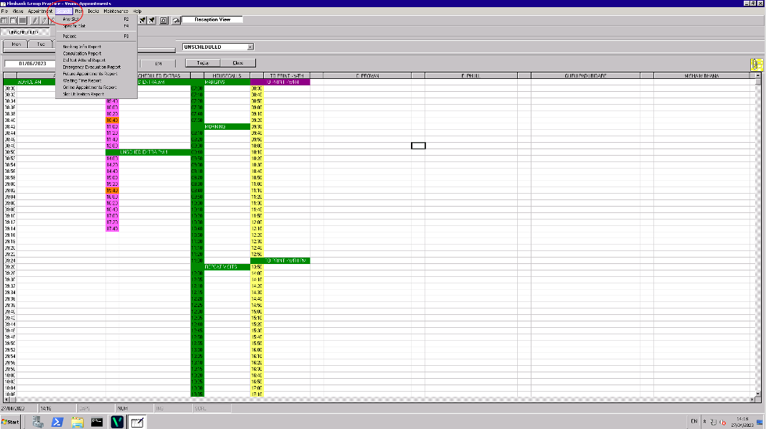

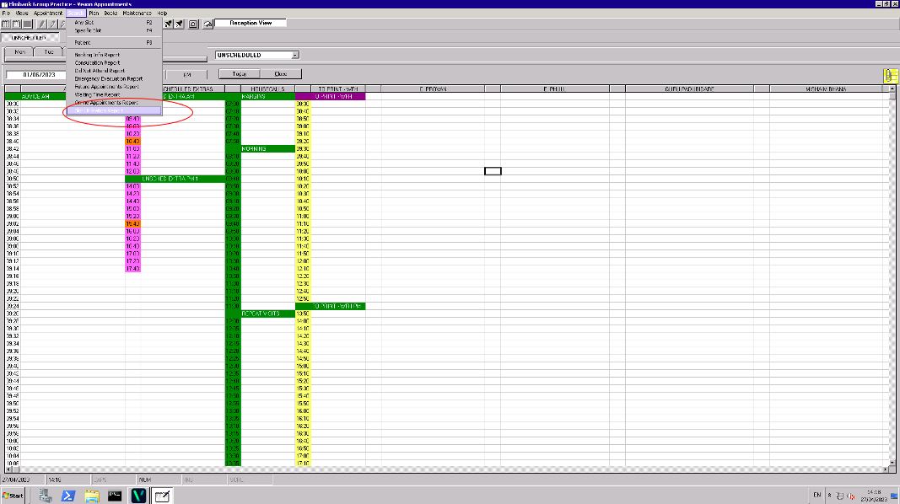

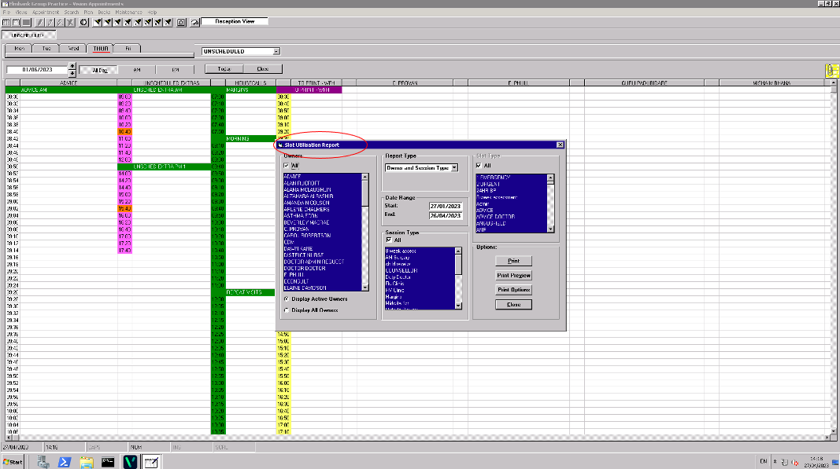

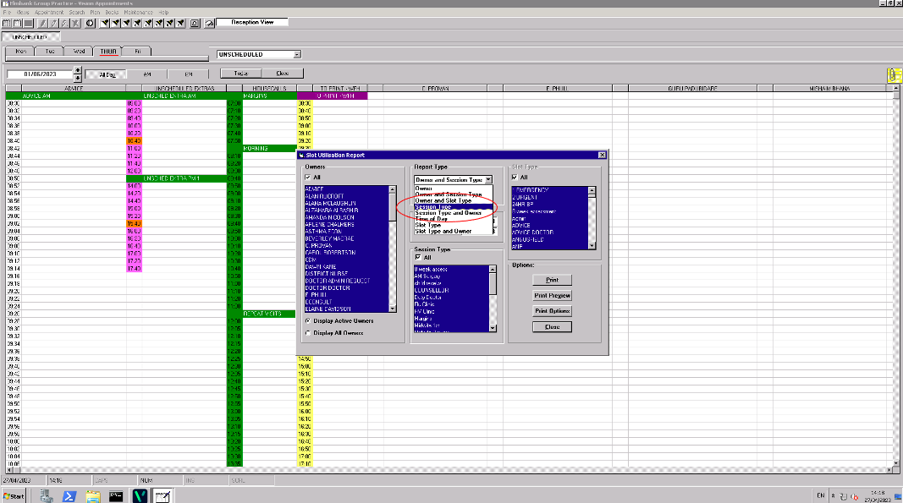

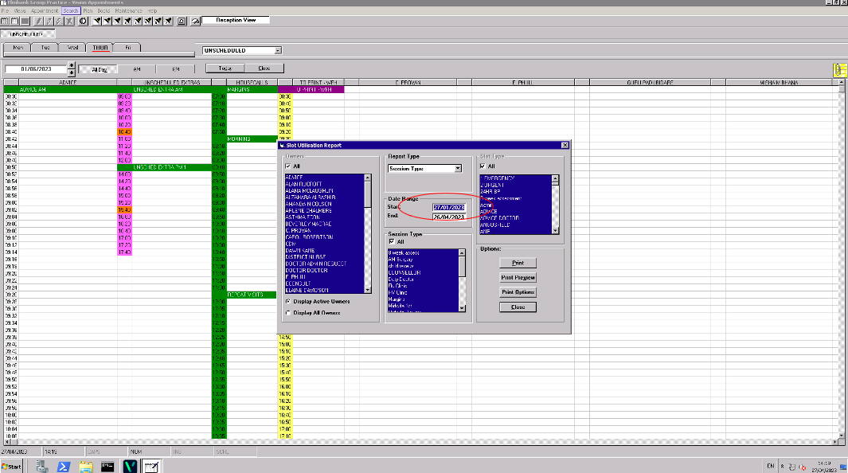

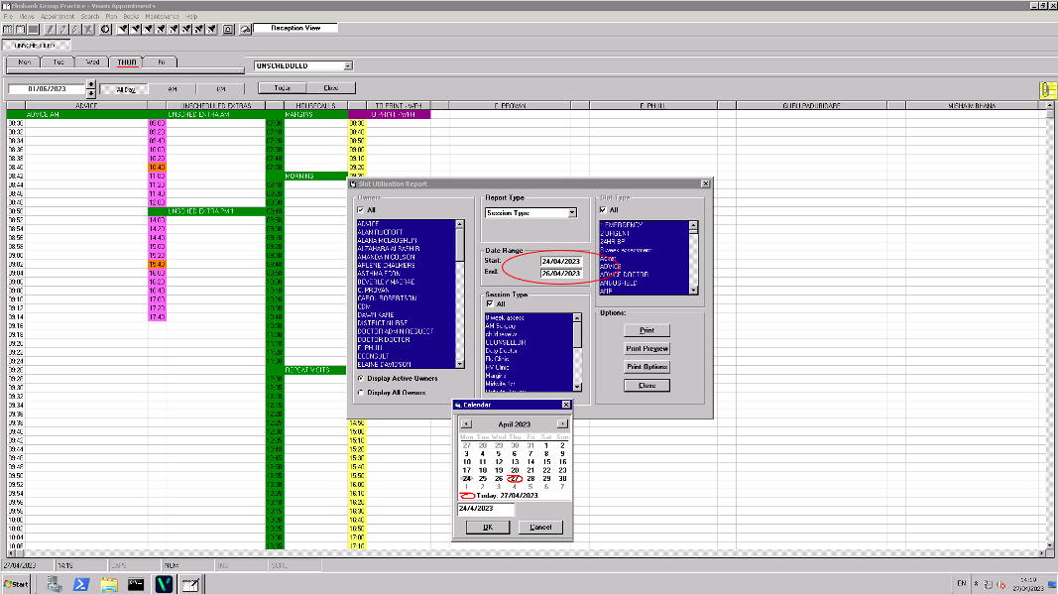

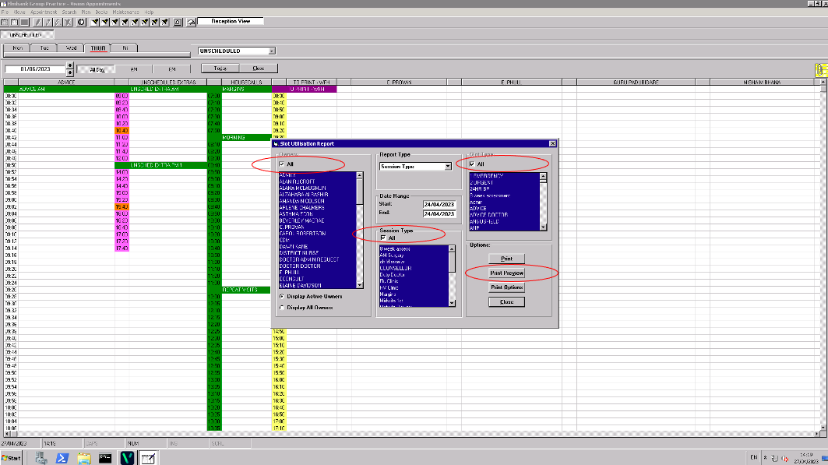

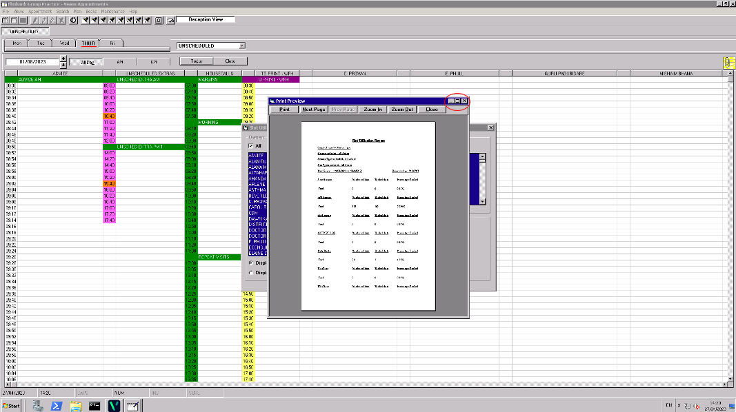

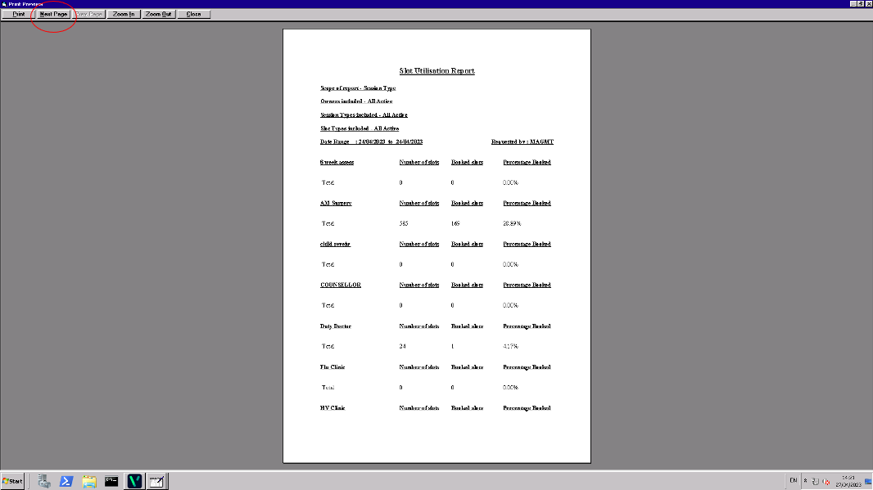

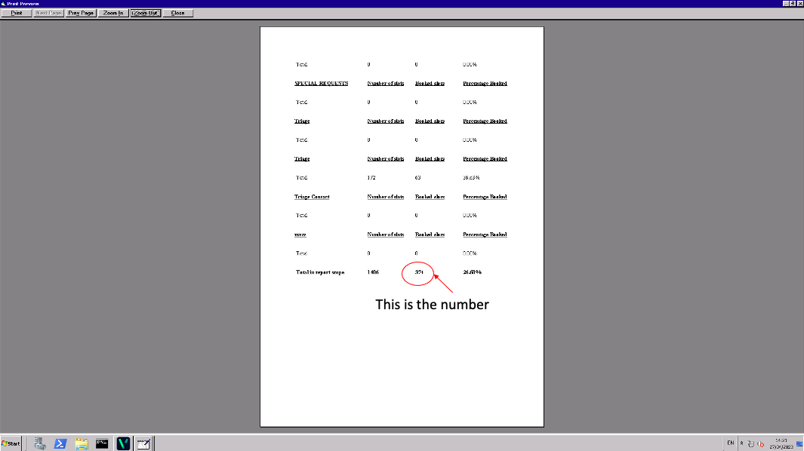

**CONTACT US**

If you experience any issues completing the form or if you have any questions, please do not hesitate to get in touch with us at [office@grampianlmc.com](mailto:office@grampianlmc.com).